Student name_______________________ Teacher ________________

Field Day 2015 T-Shirt

Order Deadline
February 26, 2015

Shirt color: Neon green
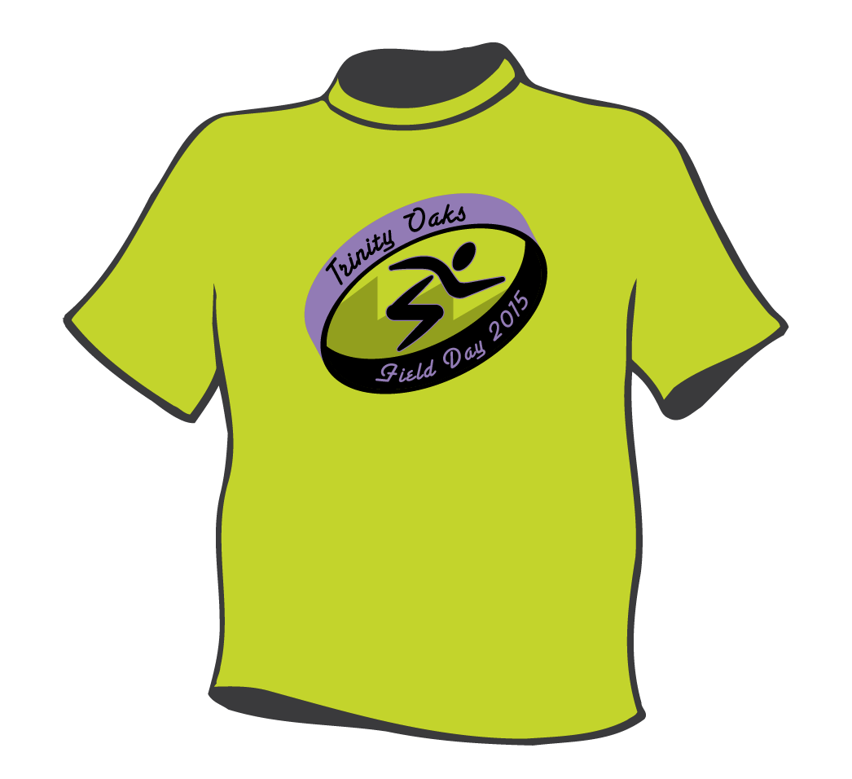
Art work: purple, black
Youth Sizes
Small Qty ______________ @ $10.00= ___________
Medium Qty ______________ @ $10.00= ___________
Large Qty ______________ @ $10.00= ___________
Adult Sizes
Small Qty ______________ @ $10.00= ___________
Medium Qty ______________ @ $10.00= ___________
Large Qty ______________ @ $10.00= ___________
X-large Qty ______________ @ $10.00= ___________
2X-large Qty ______________ @ $10.00= ___________
3X-large Qty ______________ @ $10.00= ___________

Total = ___________

Please Pay by:
Cash, Check, or Money Order

Make checks & money orders payable to:
Trinity Oaks Elementary (TOES)
MUST INCLUDE HOME PHONE # AND STUDENT ID#

Return form to the P.E. department

Questions? Contact:
The P.E. department @ 727-774-0900
agage@pasco.k12.fl.us
cmaric@pasco.k12.fl.us
smwilcox@pasco.k12.fl.us

