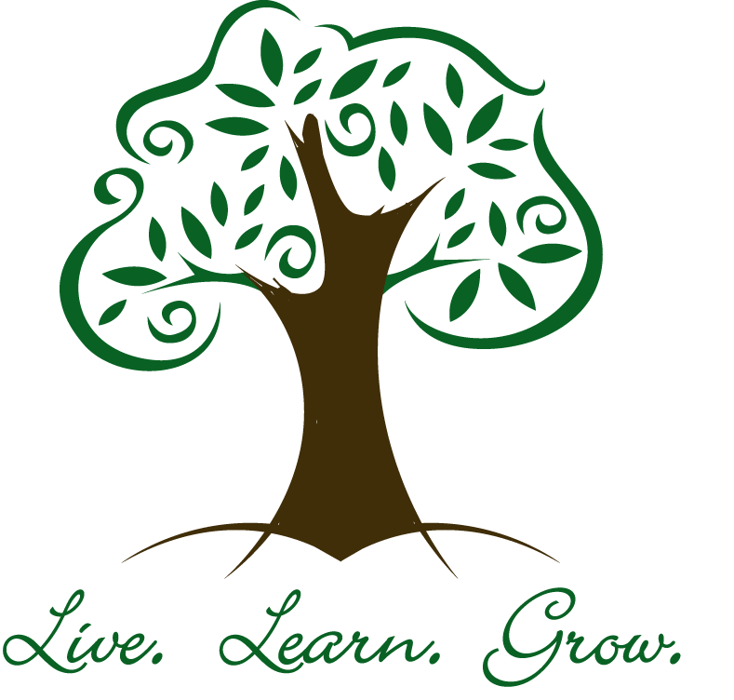

.Each student at T.O.E.S. is part of our Anti- Bully Squad. Student Council Representatives are selected 5th grade students who also serve as Anti-bully Squad leaders. As a student council/ anti-bully squad member you are trained to help other students use problem- solving strategies. These skills and strategies are taught to each student and it is expected that everyone will work together to take a stand against bullying and to promote kindness.

Student Council/

Anti- Bully Squad

Trinity Oaks Elementary

Elementary

The Developmental Guidance Program at T.O.E.S. provides every student with opportunities to develop skills, competencies, and knowledge in the following content areas: Academic, Career, and Personal/Social. Additional benefits include: focus placed on student needs and strengths, promoting academic success, enhancing student decision-making and life coping skills, and providing direct services to all stakeholders (teachers, parents, and the community.)

1827 Trinity Oaks Blvd.

New Port Richey, FL 34655

Phone: 727-774-0900

Fax: 727-774-0991

E-mail: [acohen@pasco.k12.fl.us](mailto:acohen@pasco.k12.fl.us)

Developmental Guidance Program

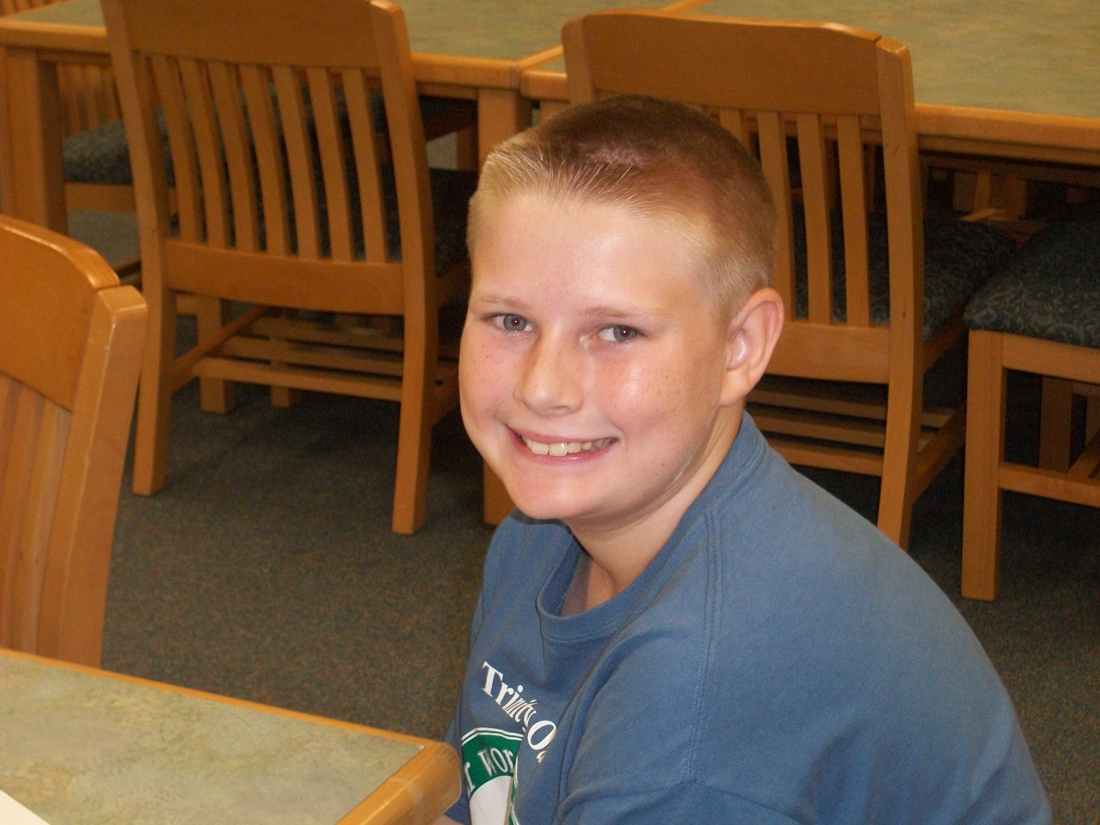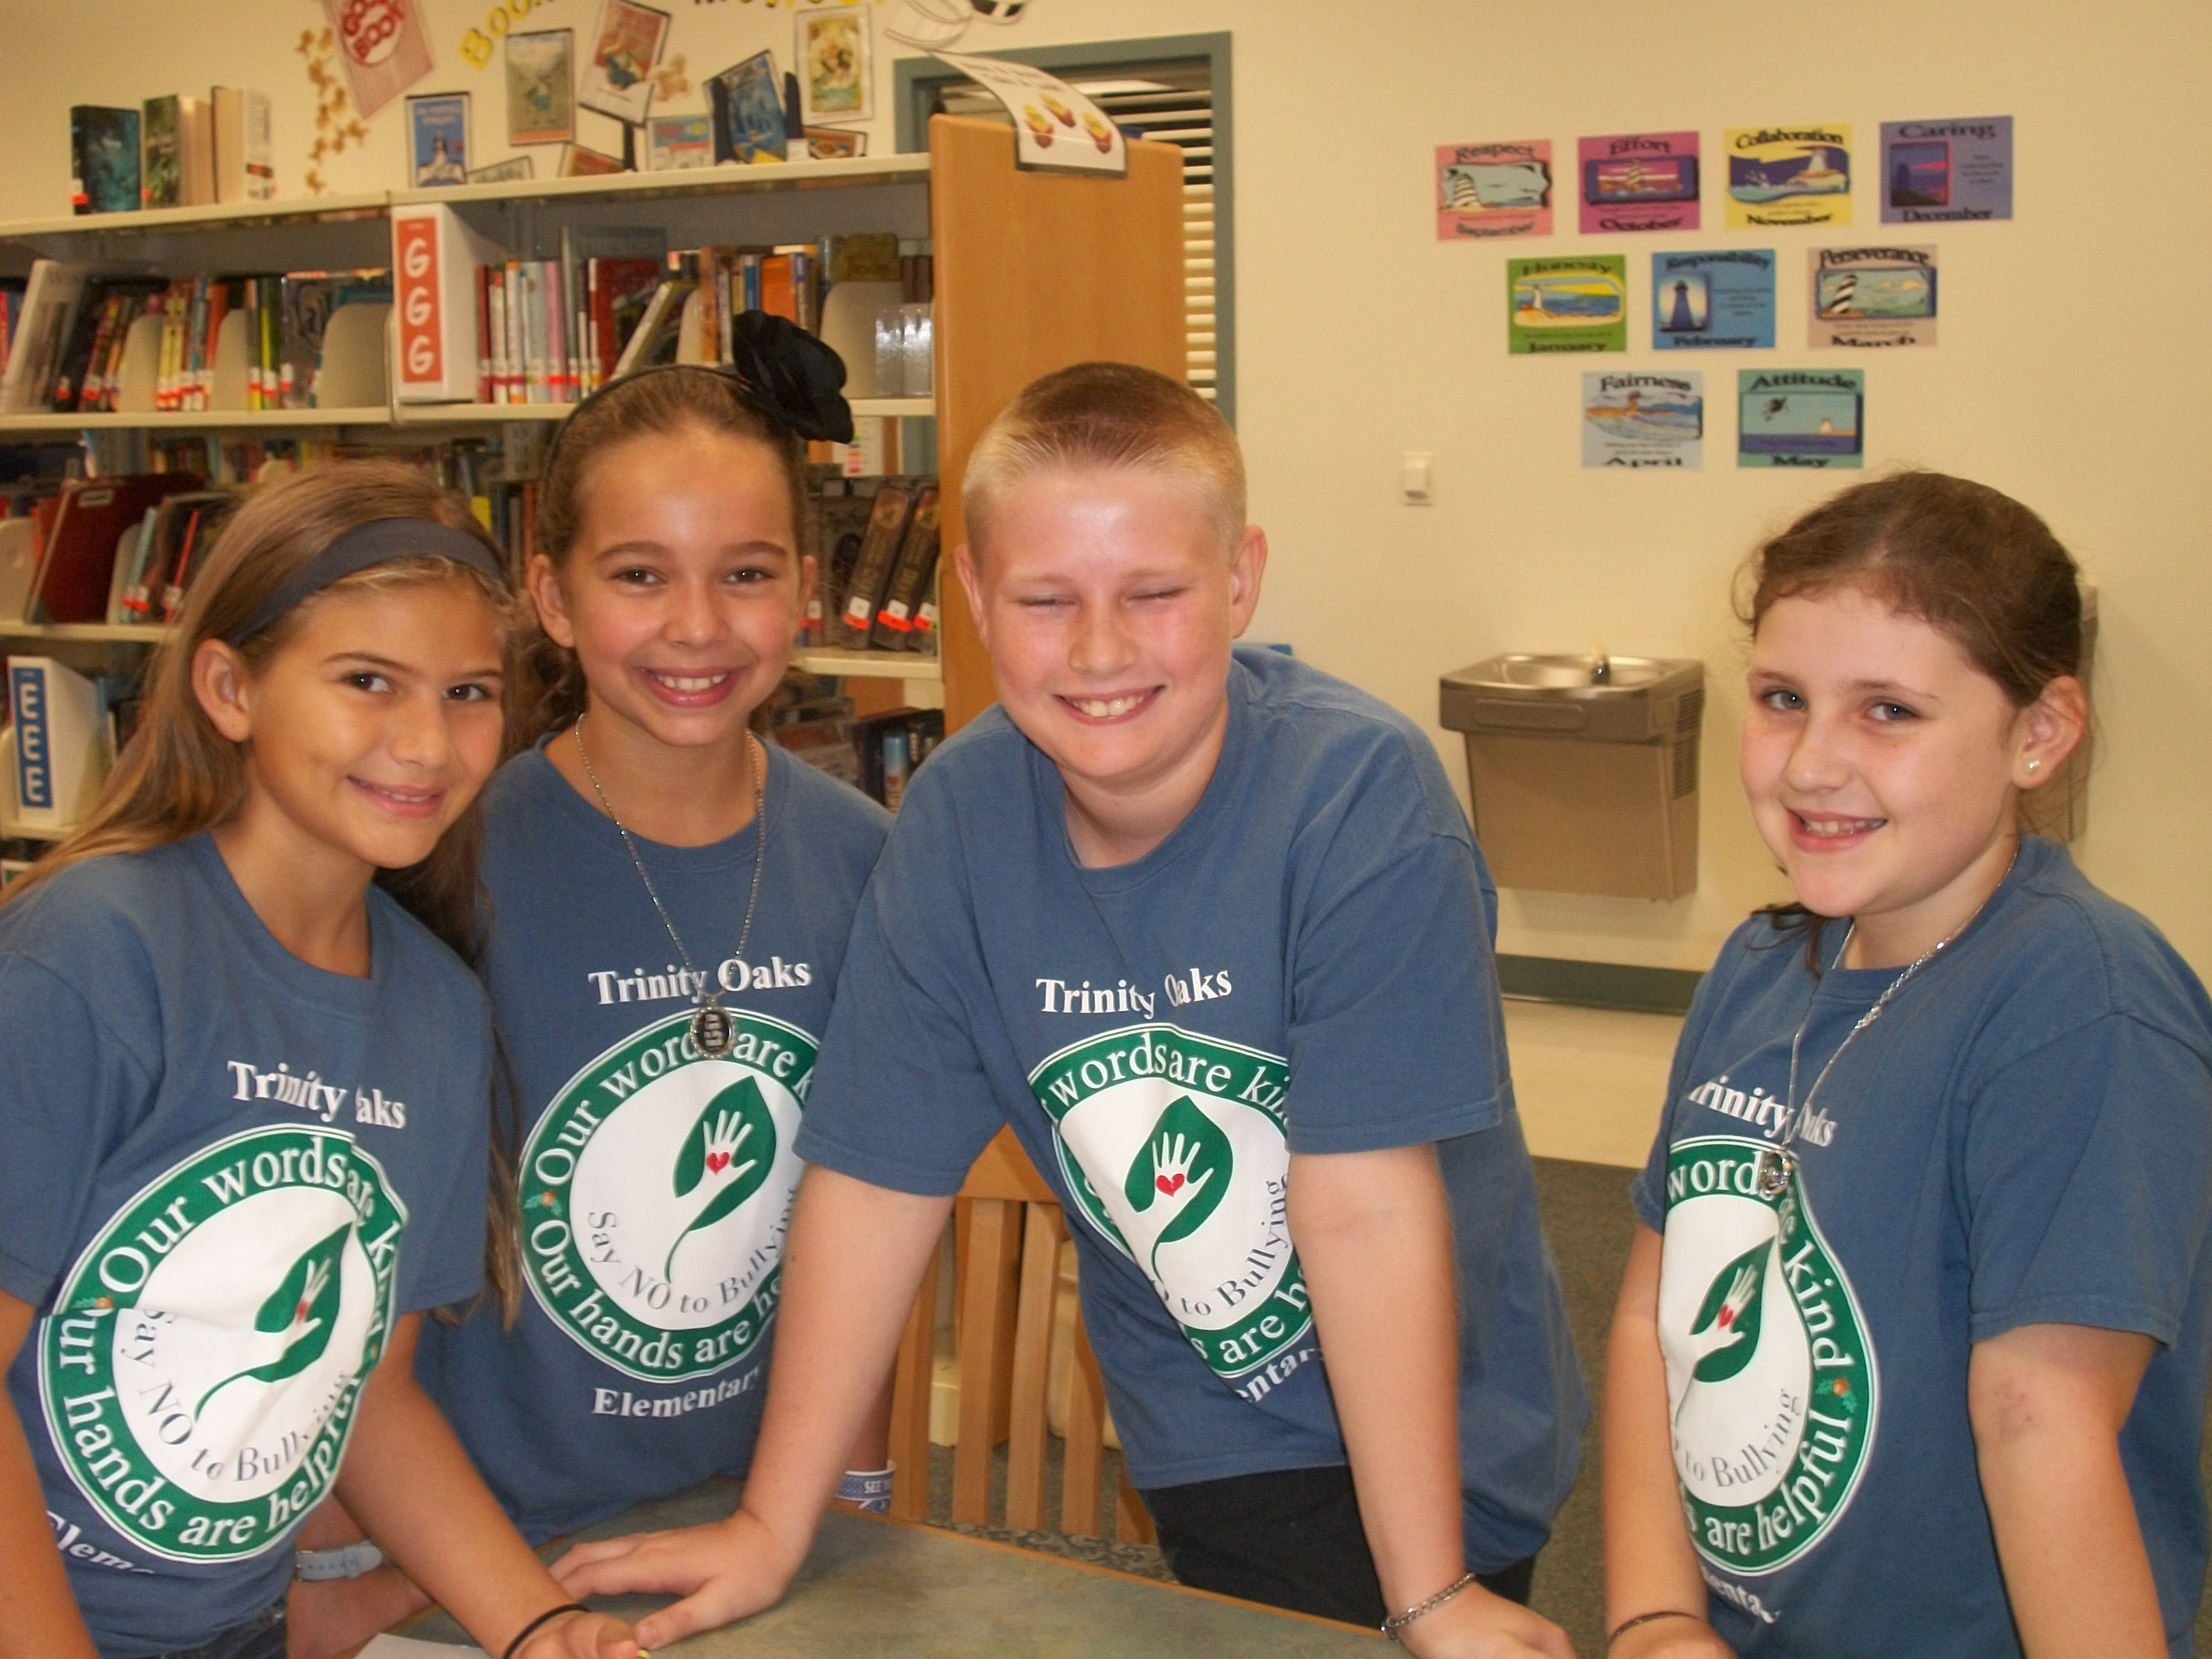

When I…

* Have good news
* Have trouble with my friends
* Have problems at home
* Need to talk to someone
* Have questions or need help with handling teasing
* Have questions or need help handling bullying.

# When should I see my counselor?

# Students will…

* Maintain high expectations that they can succeed.
* Engage in a rigorous academic program that connects with their goals.
* Be exposed to a wide range of extra curricular and enrichment opportunities.

-Be knowledgeable about how they learn and what aids their learning.

* Possess appropriate self-management skills and focus on their goals.
* Display appropriate behaviors that improve interactions with others.

# As A School Counselors I will…

* Focus on facilitating the development of the whole child by providing learning opportunities that balance the student’s mental, social, emotional, and physical well-being.
* Celebrate student successes.
* Provide learning opportunities that increase student self-confidence in their abilities.
* Promote student feelings of belonging and connection to the school environment.
* Promote students being life long learners that have a positive outlook.
* Assist students in understanding their abilities and talents and then using these abilities and talents to the fullest potential and connecting these actions with results.