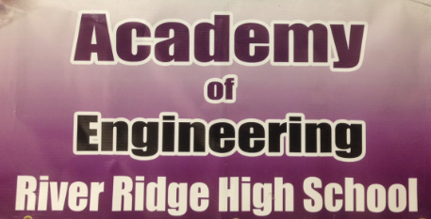

Summer stem camp
Excite your 5th – 8th grader with 5 days filled with engineering and robotics activities. Your child will get hands on while learning about bridges, robots, and engineering computer design.
Week 1 Monday June 20th – Friday June 24th
Week 2 Monday June 27th – Friday July 1st
Camp running time is 8:00 am – 3:00 pm with available early drop off at 7:30am and late pick up until 3:30pm. At 2:30pm each Friday will be the camp award ceremony.
Cost is $150.00 per week if attending for 1 week, $125 per week if attending both weeks.
Price includes a STEM Camp T-shirt and camper designed 3D printed souvenir.
Campers will need to bring their own bag lunch each day of camp. A full refrigerator, freezer, and microwave are available for camper use.
Please contact Andrew Forsman, Engineering Academy Instructor, at aforsman@pasco.k12.fl.us with any questions. Please make checks payable to RRHS Engineering and indicate campers T-shirt size on the check as well. T-shirt sizes are adult small, medium, large, and XL.

