TOES Success at a Glance
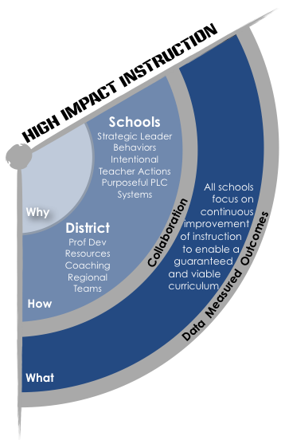
High Impact Instruction

Goal: All Student Learning Experiences Match the Rigor of the Standards

TOES Goal: TOES teachers deliver rigorous instruction and learning experiences aligned to the standards.

Strategies:
- Implement Eureka to promote engagement, understanding and independence for all learners.
- Teachers will incorporate the IPG Practices into their STEM and Humanities instructional blocks of time.
- Refine the implementation of IRLA in grades K-3 with increased accountability for student conferencing.
- Strategic implementation of IRLA in grades 4-5 for students not meeting standards in reading.

Professional Development:
- Introduction to Eureka Training Module Study Training K-5, Lead Eureka training; Use Eureka scope and sequence
- PD provided specifically in the area of conferencing and student strategies for power goal practice
- PD with the IPG tool, specifically with the core actions 2 & 3.

Monitoring  -100% of instructional staff complete module study and fluency training (via face to face or video). Monitor with participant training rosters.  -Students are able to state their power goal when asked and can describe how to practice it; Students are in the correct level; All students will have a conference at least every 9 days.  -Admin, Facilitators, and LDC monitor using the IPG Mathematics Core Action Walkthrough Guide, Quarterly Check data and the Performance Matters Platform | SMART Goal:/Targets  - By the end of the 2017-2018 school year 100% of our teachers will be implementing Core Actions 1 and 2 during Eureka mathematics instruction.  - By the end of the 2017-2018 school year, 70% of students will demonstrate proficiency on the quarterly checks in Mathematics (K-5) and Humanities (K-2) and ELA (3rd-5th).  - By the end of the 2017-2018 School year, students with a progress monitoring plan in reading will show at least a .10 growth per month as evidenced in School Pace.

TOES Success at a Glance
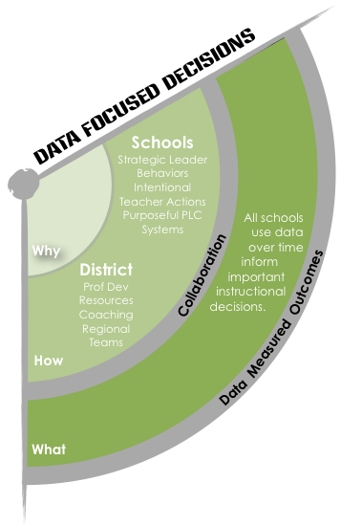
Data Driven Decisions
Goal: Increase Staff and Student Engagement

TOES Goal: TOES staff will use MTSS to increase our systems of support for all students.

Strategies:
- Establish structures (master schedules for tiers of support) purpose and connections (TBIT, SBIT, revisits) within the school for MTSS
- PLC’s use Tier 1 data to identify students who are at-risk and students who need enrichment
- Teachers utilize ELA and Math resource maps for Tier 3 support
- SLT (School Leadership Team) identifies students that are at-risk and work with teachers to monitor their progress
- SLT provides support to teachers of at-risk students
- SLT assists PLC’s in problem solving supports

Professional Development:
- District SLT Meetings
- Early Warning Systems (EWS) Professional Development with new information

Monitoring  -Admin, Facilitators, and LDC monitor student proficiency using quarterly check data  -Progress monitoring tools (EWS, quarterlies, School Pace) for Tiers 1, 2 and 3  -Data discussions and data analysis with each teacher to monitor ongoing student data monthly  -Teachers and PLC’s will monitor Eureka Math results from Mid Unit and End of Unit assessments | SMART Goals/Targets:  - By the end of the 2017-2018 school year, we will see an increase in student proficiency within each quarter as measured by quarterly checks.  - By the end of the 2017-2018 school year, we will see an increase in student proficiency for students in the lowest quartile within each quarter as measured by quarterly checks.

TOES Success at a Glance
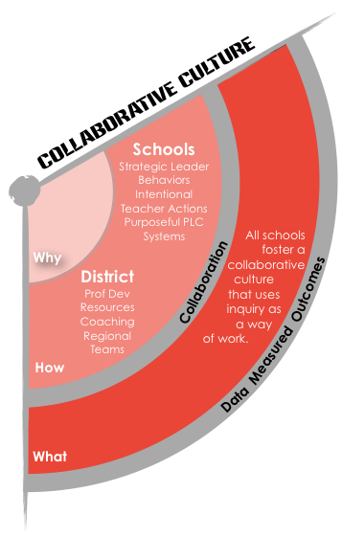
Collaborative Culture
Goal: Increase Staff and Student Engagement

TOES Goal: TOES staff will increase student, staff and parent engagement. Student On-Track attendance will increase.

Strategies:
- Growth Mindset theme across school and Staff Focus Groups
- Growth Mindset kickoff event with Vera Jones during Planning Week
- Engagement in events focused on theme throughout the year
- Staff Gallup Poll Survey
- 5th Grade Student Gallup Poll Survey
- Staff School Climate Focus Group
- Student Leadership teams and focus groups
- Clear, consistent, open and ongoing communication by teachers (to parents) and administration (Weekly updates)
- Administration conducts quarterly attendance recognition event for students
- Teachers present at Open House on the importance of on-time, regular attendance
- Administration posts school-wide attendance data on social media
- Guidance maintains attendance data and intervenes with social worker when necessary
- TOES Staff communicates with parents when a child has three consecutive absences

Professional Development:
- Early Warning Systems (EWS) Professional Development with new information.

Monitoring  -Gallup Poll Survey and Staff Climate Survey results  -Staff School Climate Focus Group feedback  -Student Leadership Discussions  -EWS data through Pasco Star and my PGS  -Data entry/teachers monitor daily student attendance  -Administration/social worker monitors weekly attendance statistics | SMART Goals/Targets:  - By the end of the 2017-2018 school year, we will increase the percentage of staff engagement to a 60% as measured by the Gallup Poll survey.  - By the end of the 2017-2018 school year, we will increase the percentage of student engagement to 76% as measured by the Gallup Poll survey.  - By the end of the 2017-208 school year, we will increase the overall parent communication given by teachers and administration.

