

Christmas

MOVIE

NIGHT

**Join us for NHS Drive-in Movie Night**

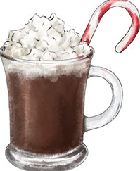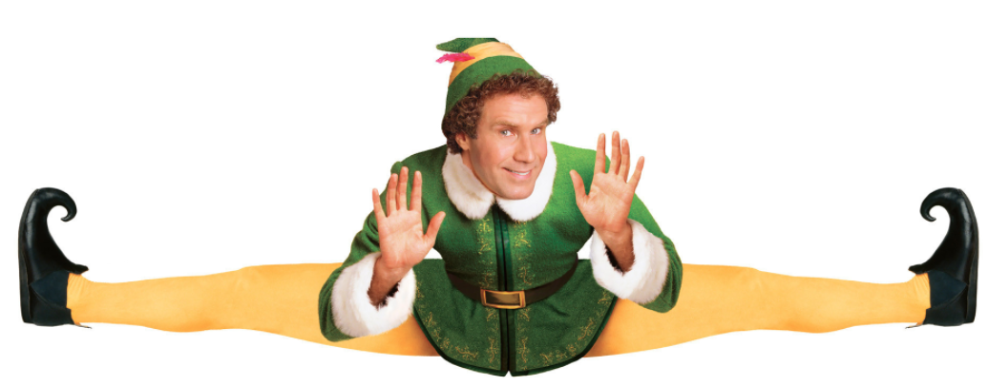

Thursday December 14th

Movie begins at 6:00 p.m.

J.W Mitchell High School,

Green parking lot

Tickets are $2.00

All proceeds will go to

Metropolitan Ministries

Cookies, Hot chocolate & Candy Canes

will be served!