Eureka Math Night
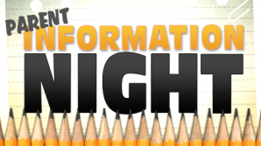
Parent Resources
- http://toes.pasco.k12.fl.us
- https://greatminds.org/math/parents
- Homework Helpers Code: 8010H000001nHcKQAU (all the 0’s are zeros).
- http://mathvillage.info/
Notes:
_____________________________________________________________________________________________________________________________________________________________________________________________________________________________________________________________________________________________________________________________________________________________________________________________________________________________________________________________________________________________________________________________________________________________________________________________________________________________________________________________________________________________________________________________________________________________________________________________________________

