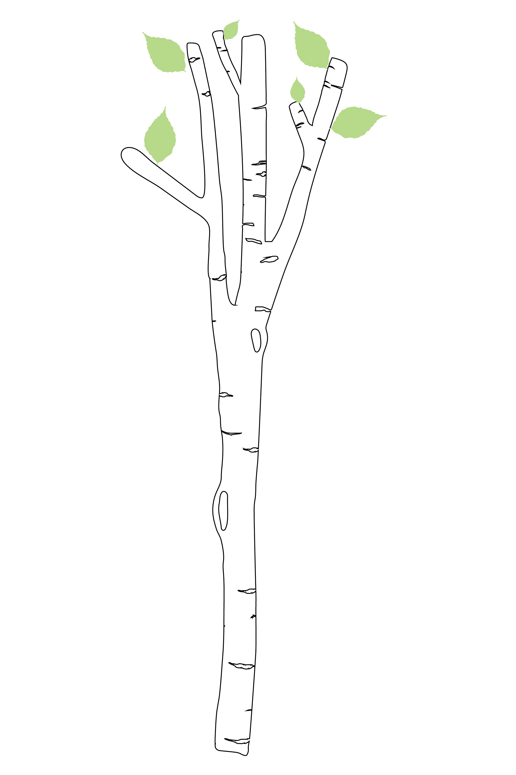
TRINITY OAKS ELEMENTARY SCHOOL
2020-2021 SCHOOL INFORMATION

Welcome Trinity Oaks Families,

We have several updates and new information to share with families before the start of the school year. We have created this document as an easy reference guide. There have been several changes and updates to the daily procedures for our school. We ask that every family review this document in, its entirety, to ensure parents and children are prepared for the first day of school. We have missed everyone and cannot wait to see the smiling faces of our Mighty Oaks on Monday, August 24th. See you soon!

Sincerely,
Mrs. Allison Hoskins and Mrs. Sandra Stine

New School Hours: 9:20 a.m. Arrival begins; 9:30 a.m. First Bell; 9:40 a.m. Tardy Bell; 4:08 p.m. Dismissal Bell

Daily Pre-entry Screener: The safety and wellness of our students and staff is our number one priority. As a daily routine, Pasco County Schools expects that all parents/guardians review the pre-entry screening tool, on behalf of their child, prior to coming on campus each day. As a school community, we must ALL be committed to keeping each other safe by staying home when necessary.

Doorbell: We have a security doorbell that was installed over the summer. Our front office doors are locked at all times. Visitors will ring the doorbell if they have an appointment and an office staff member will determine if entry to the front office is appropriate or not. Appointment times are necessary and require visitors answering the health screening questions. We are working to minimize unnecessary exposure to germs.

Communication: WE HAVE GONE ALMOST ALL DIGITAL! All school-wide and classroom communication will be posted on our website for easy reference. We will no longer be using student planners this year. School messenger will be our primary source of communication via calls and emails for priority information. Remind will also be utilized by teachers and administration to share information.
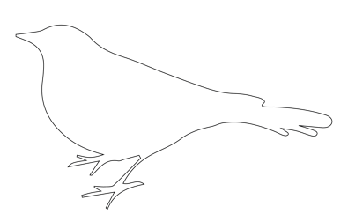
Bring Your Own Device (B.Y.O.D): Devices are going to be limited this year due to the mixture of online and in person learning. If your child, or your child's class is quarantined, we will continue learning online as much as possible. If you are permitting your child to bring a device to TOES please complete and sign the B.Y.O.D policy.

Arrival: This year, morning arrival will begin at 9:25 a.m. All students should enter campus wearing their masks. Students will not gather in the front courtyard; they will go directly to their classrooms. When students exit their vehicle in the car loop they will go straight to their classroom. Bus riders and daycare van riders will be let off school buses at 9:30 and they will go directly to class. Parents will not be allowed to park and walk their children to the front of the school in the morning. Students arriving by car will be dropped off in the car loop. We have increased morning supervision to assist with arrival and the escorting of students to class. Students needing breakfast will be able to purchase breakfast before going to their classrooms. Bikers and walking students will wait outside the school entrance gate on Trinity Oaks Blvd. and Kinsmere Blvd. until 9:20. A staff member will unlock the gate and students will enter with their masks on. Social distancing near the gate is requested. Only students are permitted past the gate entrance. Bike riders must walk their bikes to the bike rack.

PLACE Morning Drop Off: Families with students enrolled in PLACE will not be allowed to drop off after 9:00 a.m. After 9:00 a.m. all cars must join the car line.

Walkers/Bike Riders: Students who walk or ride their bike to school will enter campus through the designated gate. Parents are not permitted beyond the gate. Staff will be assigned to supervise the area and assist students as needed. Please do not arrive too early. Gates will open at 9:20 a.m.

Visitors/Volunteers: During the 1st semester, we will not have any visitors on campus. We will have limited volunteers and no volunteers working directly with students. We will not have any field trips during the first semester, and are unsure, at this time, if students will be taking any field trips during the second semester. Volunteers will need to sign up and be approved. The front office doors will remain locked, and visitors will be let in by appointment.

Classrooms: All students will be socially distanced in our classrooms. School carpets are stored and soft seating is put away. Classrooms are decorated more minimally to clean the walls, furniture, door handles, light switches and other surfaces throughout the day. School technology will be cleaned before each student uses it. Books in our classroom libraries will be quarantined before use as well.

Curriculum: This school year our students will be engaged in curriculum that can be taught in-person and online. If a student is not feeling well and needs to stay home the curriculum is versatile and students can continue to learn while they are home.

Specials: Students in our on-campus setting will participate in either art, music or P.E. daily. Our art and music teachers will be providing instruction in each classroom. P.E. will take place outside on campus on good weather days.

Clinic Procedures: When students need Band-Aids, tooth boxes, or ice we will accommodate those needs in our classrooms this year. If a student is sick or has COVID-like symptoms they will need to be picked up from school immediately from our sick clinic. *All district protocols will be followed regarding cleaning, sanitation, referring to the school nurse, and the district COVID Team.

Students on Campus: This year, students will not be visiting other parts of the campus without their teacher. Students are not permitted to run errands or walk with a buddy. Media books will be brought to the classroom.

Lunch Room: Our lunchtimes have been extended to sanitize tables and serving lines between classes. Students will be sitting as a class in the lunchroom. Students will be socially distanced and faced forward in the same direction. We will not have visitors during the first semester, and no outside food can be brought in. Some students might choose to bring in a snack that can be consumed quickly, in the classroom, due to an earlier or later lunchtime (i.e., granola bar).

Cafeteria purchases: Students will not be able to purchase snacks in the cafeteria, at the start of the school year. We are determining whether to offer this in October or not. To encourage our younger Oakies to eat their lunch, Kindergarten and 1st grade will not be offered snack purchases until later in the second quarter. Parents are encouraged to sign up for a lunch account online with MySchoolBucks.com, where they can add funds electronically. Parents are also encouraged to purchase items through the cafeteria for class celebrations. Teachers will provide more information as a class celebration nears. Outside food is not allowed to be brought in and shared with other students.

Recess: All classes will have 20 minutes of recess scheduled daily. Cohorts will be assigned a designated area to ensure social distancing. The playground will be sanitized between each use.

Dismissal: Dismissal will begin at 4:00 p.m. during the first semester of school. Students will receive a colored band that should be attached on the top handle to their backpacks. The color band signifies how students are going home. These bands must remain on your student’s backpack for the first two weeks of school. To maintain social distancing and limit the mixing of cohorts, we will not gather groups of students in an area for dismissal. Students will be dismissed directly from his/her classroom. Students riding school buses and daycare vans will remain in their classroom until they hear their bus number and color called on the overhead PA system. Walkers and bike riders will be dismissed together. Students are to continue wearing their masks at least until they are off campus. Parents are not able to enter campus.

Car Rider Families: Parents should remain in their vehicles and have their car tag visible. Florida Law states that cell phone use is prohibited when operating a vehicle on school property. We are piloting an electronic dismissal system. When cars arrive on campus with their car tags displayed school staff will enter their student’s car number into the iPad or cell phone. The number will then be displayed in each classroom on the white board. The teacher will then release the student for car loop pick-up.

Dismissal Transportation Change: When a parent needs to request a change in the way their child goes home, the request must be made online prior to 3:15 p.m. The link to request a change is located on the school website. It is vital to have a consistent plan for dismissal every day so that your child is confident about how they are getting home.

Early Pick-up: No one is allowed on campus without an appointment. Parents who need to pick-up their child early from school will need to call the front office to pick up before 3:15 p.m. Once you arrive on campus, ring the doorbell at the front office, have your license ready to be scanned and an office staff member will assist you at the door. Your child will be walked out to you. There will no exception made to this pick-up time.

Afternoon PLACE Pick-up: Afternoon PLACE pick-up will begin at 4:30 p.m. in the car loop. Children will not be called out of PLACE, to the car loop, for dismissal.

Sanitation/Bathrooms: Procedures have been established so that classes within the building share a bathroom with only their cohort. Bathrooms will be sanitized throughout the day.

Masks: Based on the district’s expectations, students will be expected to wear a mask throughout the day, except during PE, when following social distancing guidelines. Teachers will schedule mask “breaks,” and students will be able to remove his/her mask during lunchtime. We purchased lanyards and mask holders designed to hold a mask when the student is not wearing it. Parents are encouraged to put your child’s name on their masks. Students should wear a clean mask daily.

School fees: School fees can be paid online through Student Quick Pay. (Account set-up may occur 24 hours after a Parent Portal Account is created.) 2020-2021 School fees are $29.00. (General Fee ($10), Art/Music/PE Fee ($10), Special Project Fee ($7), and Technology Fee ($2) Parents can also use link on the Pasco County Website under the parents’ tab for quick access to pay school fees.

Due to limited fund-raising opportunities school fees will be a critical source of needed funds.

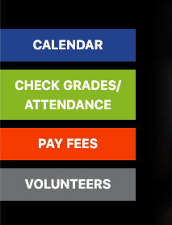

Early Release Days: Pasco County will not have any early release days the first semester of the 20-21 school year.

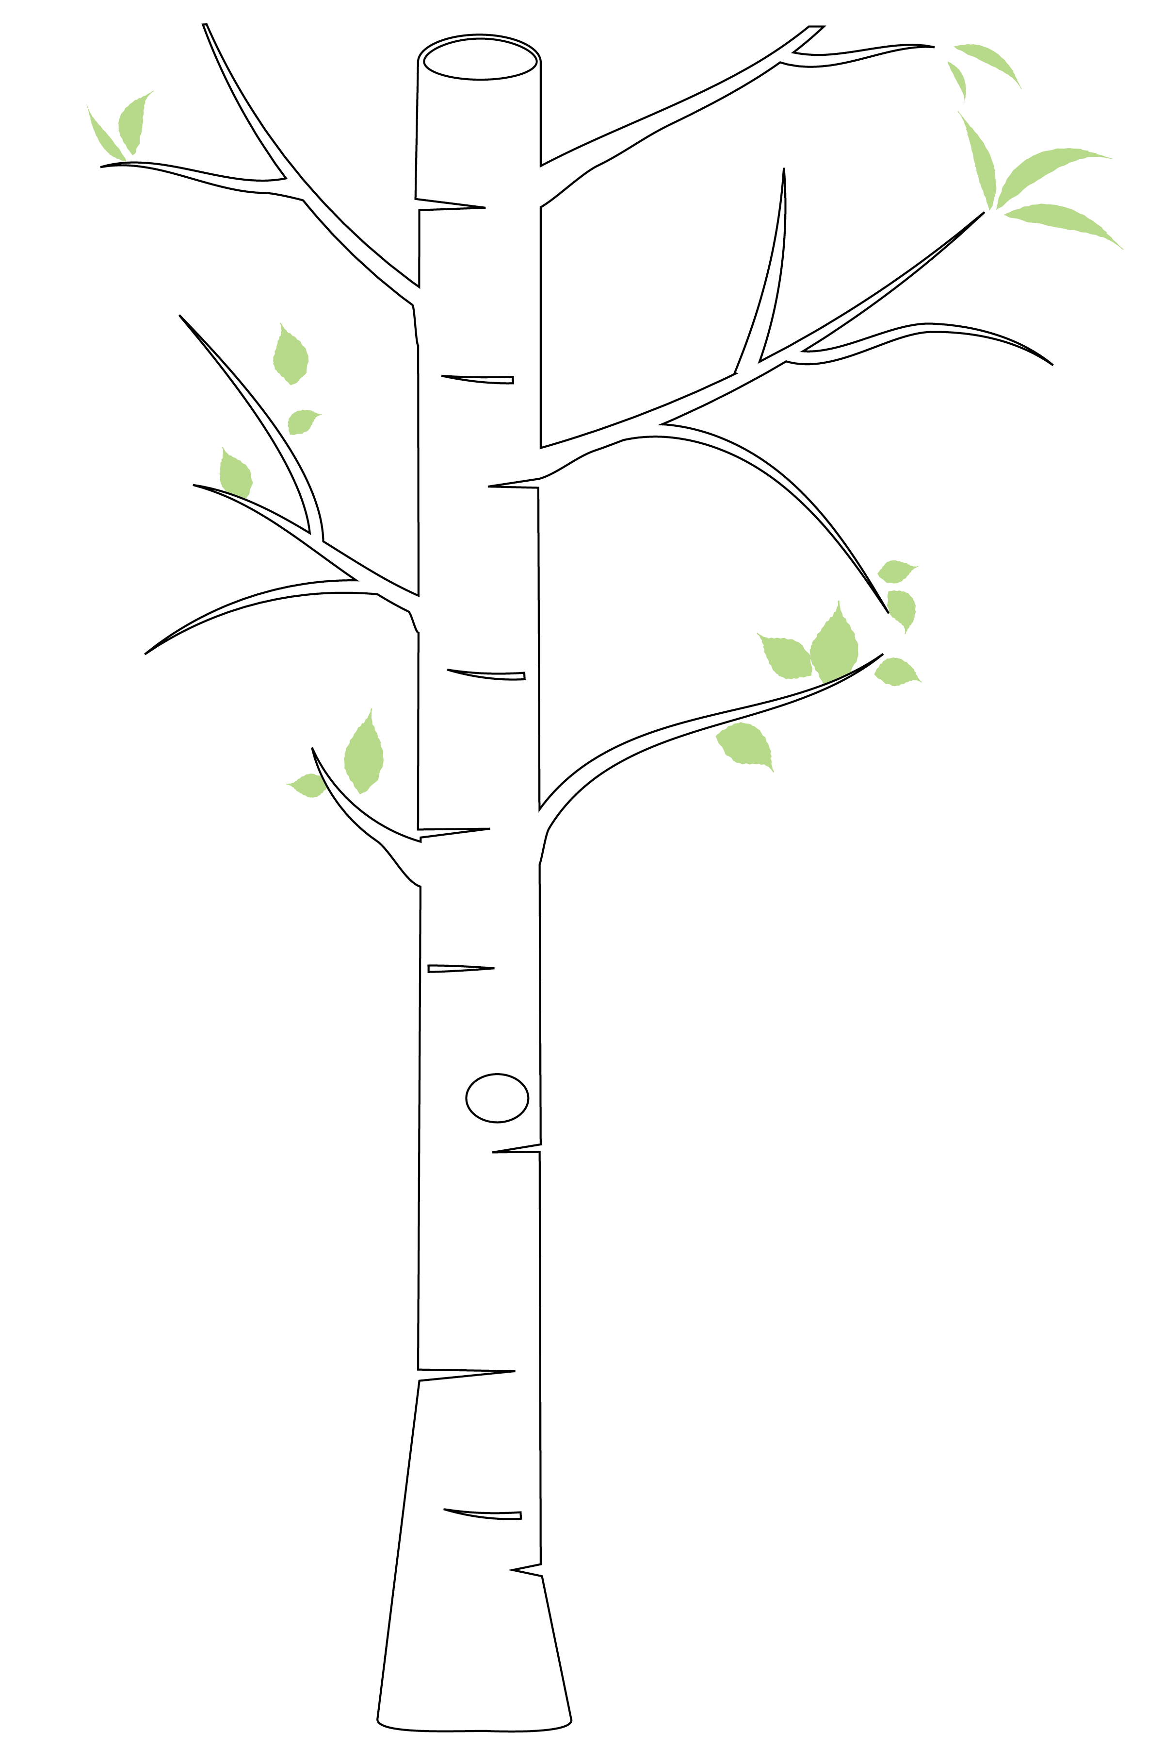
Parent Portal: Report cards and other essential information will be shared via the parent portal. Please sign up for a parent account. New Pasco County students will need a student number and parent pin number. Please contact the front office for this information 727.774.0900

Emergency Cards: Emergency cards can now be found in your Parent Portal account. Please complete them as soon as possible.

1st day of school: For the safety and wellness of students and staff, ONLY Kindergarten families will be allowed to park and walk their child to their classroom doors on the first day of school, August 24 at 10:00 a.m. Parents will not be allowed into the classrooms. To minimize crowding, we will delay the beginning of school for our Kindergarteners. Families will be allowed to enter campus and walk their child to class at 10:00 a.m. We want this to be a memorable time for families, but we also need to follow social distancing guidelines.

Beginning of the Year Kindness Information Folder: Every family will receive a take home folder at their assigned Meet the Teacher Drive Thru Event. We will also disperse the following items
- Printed copy of the 2020-2021 School Information document
- Based on what has been communicated as your child’s way of going home
  - Car Rider Tags and backpack band or
  - Bus Rider Pass and backpack band or
  - Walker/Bike Rider backpack band or
  - Daycare Van Rider backpack band
- Student Insurance form

PTO: Join the PTO and help us continue to promote collaboration, achievement and community building at Trinity Oaks. Your support goes a long way!

Friday Shirts: This year our school will continue with our Oakie Kindness theme that represents the focus of the character building we have planned for our students. Students who have a school shirt from last year can continue to wear that one. For new students and growing students, you can purchase a new shirt. School shirts are $15.00 through Student Quick Pay online.

School Events: All of our school clubs are postponed at this time. Our PTO events involving school activities with the gathering of students and their families are postponed, as well, until further notice.

