

Everyone including students, staff, parents, and community are part of our Anti- Bully Squad. Student Council Representatives are selected 5th grade students who also serve as Anti-bully Squad leaders. Problem solving skills are taught to all students and it is expected that everyone at T.O.E.S. will work together to promote kindness and take a stand against bullying

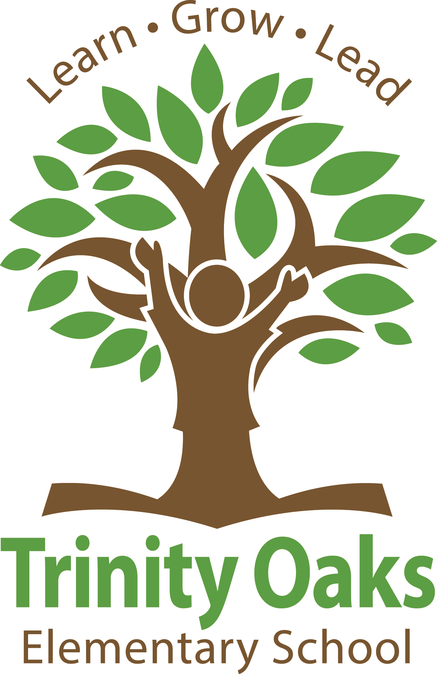

DEVELOPMENTAL

GUIDANCE

PROGRAM

Student Council/

Anti- Bully Squad

The Developmental Guidance Program at T.O.E.S. provides every student with opportunities to develop skills and knowledge in Academic, Career, and Personal/Social content areas. Focus is placed on student needs and strengths. This promotes academic success that enhances student decision-making and life coping skills which provides direct services to all stakeholders (teachers, parents, and the community.)

1827 Trinity Oaks Blvd.

New Port Richey, FL 34655

Phone: 727-774-0900

Fax: 727-774-0991

E-mail: [acohen@pasco.k12.fl.us](mailto:acohen@pasco.k12.fl.us)



When I…

* Have good news
* Have trouble with my friends
* Have problems at home
* Need to talk to someone
* Have questions or need help with handling teasing
* Have questions or need help handling bullying.

# When should I see my counselor?

# Students will…

* Maintain high expectations that they can succeed.
* Engage in a rigorous academic program that connects with their goals.
* Be exposed to a wide range of extra curricular and enrichment opportunities.

-Be knowledgeable about how they learn and what enhances their own learning.

* Acquire appropriate self-management skills and focus on their goals.
* Display appropriate behaviors that improve interactions with others.

# As A School Counselors I will…

* Focus on facilitating the development of the whole child by providing learning opportunities that balance the student’s mental, social, emotional, and physical well-being.
* Celebrate student successes.
* Provide learning opportunities that increase student self-confidence in their abilities.
* Promote student feelings of belonging and connection to the school environment.
* Encourage students to be life long learners with a positive outlook on life.
* Assist students in understanding their abilities and talents. Encourage them to use these abilities and talents to their fullest potential .