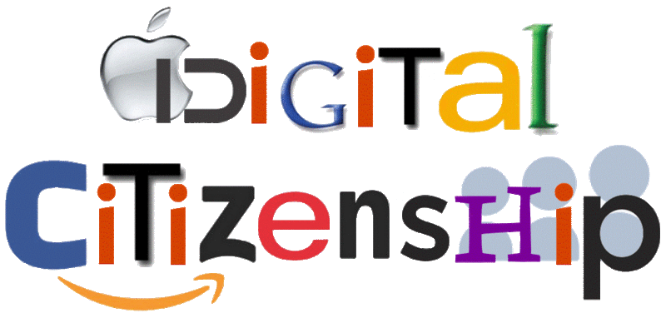

Students are spending more time online than ever before, both to complete schoolwork and for fun. How can we remind students at Trinity Oaks that it is important to be safe, responsible, and respectful?
We need your ideas!

Digital Citizenship | Novice (1) | Apprentice (2) | Practitioner (3) | Expert (4)
Staying Safe Online | - Can define private and personal information.  - Can explain why some information should not be shared online. | - Can give examples of safe information to share online.  - Can give examples of unsafe information that should not be shared online. | - Can evaluate whether a given password is/is not safe.  - Can evaluate whether information should be shared or not shared online. | - Can create and use safe passwords.  - Shares only safe information online.
Using Social Media and Digital Resources  Responsibly and Respectfully | - Can define personal and private information  - Can name beneficial offline activities.  - Can define cyberbullying  - Can define online source | - Can name online responsibilities  - Can explain the benefits of balancing time on/off line.  - Can name examples of cyberbullying  - Can give examples of online sources | - Can explain why online responsibility is important.  - Can identify situations in which using digital devices would be inappropriate.  - Can name appropriate actions to take if being cyberbullied or seeing cyberbullying occur.  - Can explain a way to give credit to an online source | - Can name examples where an online action goes against an online responsibility.  - Can name actions that would not be appropriate in a cyberbullying situation.  - Can give examples of improper use of online sources.

