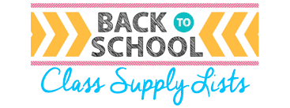

Ms. Mohrmann’s 2^{nd-}3rd Grade List

Supplies Needed:
(2) 1” binder with clear outside plastic cover (any color)
(4) pocket folders with prongs (red, blue, green, yellow)
(1) package dividers
(1) box of Crayola crayons
(1) package of washable markers (thick or thin- preferably Crayola)
(1) package of pencils
(1) pencil box with student name
(1) pair of student scissors (preferably Fiskars)
(2) packages of glue sticks (preferably Elmer’s thick glue sticks)
(1) package of dry erase markers (thick or thin)
(1) box kleenex
(1) box of either quart or gallon baggies
(1) container of hand sanitizer
(1) container of sanitizer wipes
(1) box/bag favorite snack/candy to share

Wish List: $5-10 Target/Walmart giftcard to buy extra classroom supplies, books, and sanitizing supplies

Thank you so much for all of your support in getting your child ready for school. Please make sure your child’s name is written on all their school supplies. Students will not be permitted to share any school supplies; therefore, each student will need an individual pencil box for all their supplies.

